BLOND:ISH

2016
Technical Specifications

Tour Manager:
Tel. Email.

Front Of House Engineer :
Tel. Email.

Here is a list of specifications we require from the PA. If there are any concerns with any of the requirements please let us know and we can discuss.

- A high quality stereo PA with a frequency range of 20Hz up to 20Khz.
- The PA should include subs (no vocal PA’s) and handle levels up to 110dB’s with no distortion (even where there are dB limits we do not want the PA distorting at the dB limit of the venue).
- The PA should not be limited below 110dB’s. Please contact us to discuss if this is the case.
- We require a mixing desk with at least 32 channels with a parametric EQ on every channel, 8 auxs, and sweep-able hi-pass filters. I will also use 4 channels with parametric EQ for the two stereo FX returns.
- We need a three-way monitor mix with 6 monitors all with a 31 band graphic equaliser.
- We need a graphic equaliser on the front of house PA, in stereo with at least 31 bands each (left and right).
- We need 14 compressors (preferably BSS, DBX or similar).
- 1 tall boom stand and 1 small boom stand all with own mic clips.
- We need 11 DI boxes.
- We need two FX units with separate sends and returns to the desk (preferably either TC electronic M-One, M2000, M3000 or M4000).

VISUALS REQUIREMENTS
- We will require a HDMI input into a high quality projector (provided by the venue) from stage left.
- If indoor we require indoor 6-12K , 0.7-1.1 lens and if outdoor we require 12-20K lumens , 0.7 - 1.1 lens.
- Suitable projectors are Christie, Barco or Panasonic.
- HDMI to cat5/6 or Fiber adaptors
- Cat5/6 or Fiber extensions (10 to 30 meters)
*** VERY IMPORTANT *** - Please double check with management on the following which is dependent on each venue:
Wall Space for Projections - Send the floor plan of the venue and photos of the venue with accurate measurements. We need this to assess the wall space for the projections.
Truss - depending on your venue, we might need a truss.

BACKLINE REQUIREMENTS

We require 3 rustic wooden tables of the following measurements:
- Table Stage Left (50cm Height, 90cm Width, 200cm Length) with 2 stools (45cm Height, 35cm Width, 35cm Length)
- Table Centre Stage (100cm Height, 90cm Width, 100cm Length) no stool.
- Table Stage Right (50cm Height, 50cm Width, 100cm Length) with 1 stool (45cm Height, 35cm Width, 35cm Length)

VERY IMPORTANT

On some shows we do not travel with Corey our singer. In which case we will not require the following:
- Channels 9, 10 and 13
- The Table Centre Stage (100cm Height, 90cm Width, 100cm Length) no stool.
- Or mix two with two wedges.

Please contact us in regards to whether we will be traveling with Corey or not.

DECOR REQUIREMENTS

The concept of the live show is a sit down listening experience.
We require:
- comfortable cushions
- decorative carpets
- low tables
- ambient lighting ie. battery powered candles, soft lighting away from the stage
and whatever necessary to create a comfortable environment for guests to enjoy the show.

We also have 2 suitcases full of decorations for the show that we will be bringing with us and that we will need someone from your team to setup if we do not have our decorator with us on tour.

Reference video here https://vimeo.com/153057767

Finally we would prefer no Behringer or Peavey equipment and all digital desks should be supplied with a trained engineer. Suitable digital desks are LS9, PM5D, DigiCo, Digidesign, Vi6 or similar spec desk.
No Yamaha digital desks below the specification of the LS9 including the Allen and Heath iLive series. If this is the case please contact us and we can arrange an alternative.

If there are any questions or queries please contact us.

Thank you very much and we look forward to working with you.

BLOND:ISH - 2016

Stage Plan and Channel List

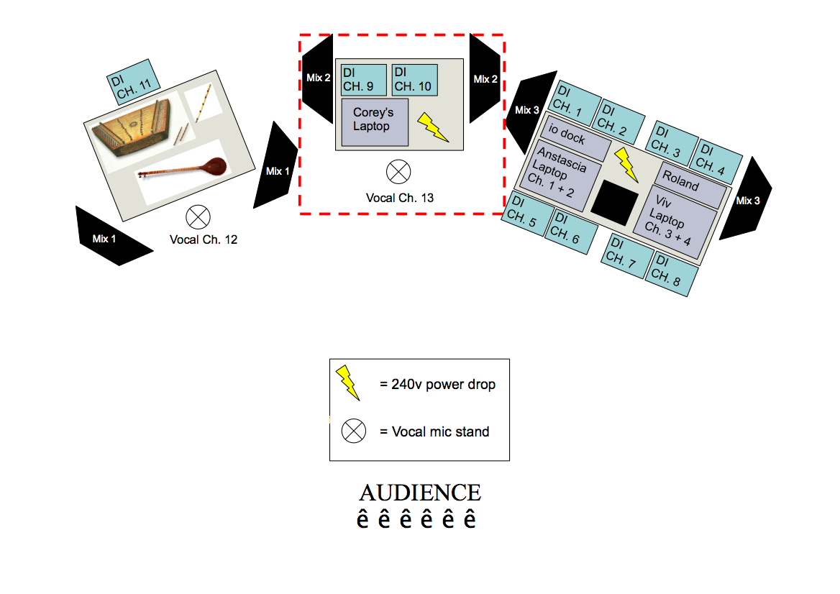

Tour Manager:
Tel.
Email.

TM & FOH Engineer:
Tel.
Email.

Channel | Instrument | Microphone | Stand | Stage Position | Phantom Power | Inserts
1 | Anstascia Laptop Left | DI |  | Stage Left | 48V | Compressor
2 | Anstascia Laptop Right | DI |  | Stage Left | 48V | Compressor
3 | Viv Laptop Left | DI |  | Stage Left | 48V | Compressor
4 | Viv Laptop Right | DI |  | Stage Left | 48V | Compressor
5 | Iodock Left | DI |  | Stage Left | 48V | Compressor
6 | Iodock Right | DI |  | Stage Left | 48V | Compressor
7 | Roland Drums Left | DI |  | Stage Left | 48V | Compressor
8 | Roland Drums Right | DI |  | Stage Left | 48V | Compressor
9 | Corey’s Laptop Left | DI |  | Centre Stage | 48V | Compressor
10 | Corey’s Laptop Right | DI |  | Centre Stage | 48V | Compressor
11 | Santur | DI |  | Stage Right | 48V | Compressor
12 | Vocal and Instrument Mic | Senn. e935, E945 or SM58 | Short Boom | Stage Right |  | Compressor
13 | Vocal Centre (Corey) | Senn. e935, E945 or SM58 | Tall Boom | Centre Stage |  | Compressor
14 | Spare Vocal | Senn. e935, E945 or SM58 |  | Centre Stage |  | Compressor
15 | FX Return 1 Left | LONG WARM HALL REVERB
16 | FX Return 1 Right | LONG WARM HALL REVERB
17 | FX Return 2 Left | TAP DELAY
18 | FX Return 2 Right | TAP DELAY
19 | Ipod L
20 | Ipod R
21 | Talk to stage | Any Switch Mic

- Please read note on page one in regards to channel 9, 10 and 13.
- The black box on the right table (in between Anstascia & Vivie-Ann’s laptops, is the video server laptop. This is where the visuals will be fed from for the projector. Please make sure the HDMI / CAT5 cables.

